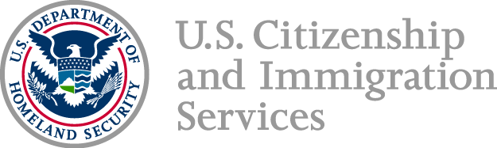

Immigration Representative

Meeting Invitation

**USCIS San Francisco Field Office**

630 Sansome St., Room 1050, San Francisco, CA 94111

*Thursday, October 3, 2019*

*9:00am to 10:00am*

The USCIS San Francisco Field Office invites you to a stakeholder meeting geared toward immigration practitioners who represent clients at the field office and are interested in local USCIS operations. This meeting is open to all interested parties. Attorneys, accredited representatives, and law students supervised by an attorney are suggested to attend. During this meeting, USCIS staff will provide local updates and respond to pre-submitted questions.

Questions can be submitted in advance to the local Community Relations Officer at [SFSJ.CommunityRelations@uscis.dhs.gov](mailto:SFSJ.CommunityRelations@uscis.dhs.gov) no later than September 26, 2019. Questions pertaining to specific cases, national policy, or legal interpretation will not be addressed.

If you need a disability accommodation to participate in the meeting, please write to [SFSJ.CommunityRelations@uscis.dhs.gov](mailto:SFSJ.CommunityRelations@uscis.dhs.gov) by September 26, 2019.

**Note to Media**: This engagement is not for press purposes. Please contact Sharon Rummery at (415) 248 8873 for any media inquiries.

We look forward to seeing you!