U.S. Citizenship and Immigration Services (USCIS)

July 2014 Monthly Web Metrics Report
Customer Service Web Portal (CSWP)

August 18, 2014

Revision History

Version | Date | Name of Author | Summary of Changes
1.0 | August 18, 2014 | CSWP, Senior Business Analyst | Baseline Draft

Table of Contents

Executive Summary 1
CSWP Visitor Traffic 2
Top 25 Browser Versions Used by Visitors to USCIS.gov 3
FOIA Status Check 4
Top 25 Viewed Pages 5
Top 25 PDF Page Views 6
Top 25 Referring Sites Sending Traffic to CSWP 7
Top 25 Search Terms from Referring External Search Engines 8
Top 50 Search Terms Entered into the CSWP Search Engine 9
Surveys of User Satisfaction 10
Social Media Activity Using Links on CSWP Pages 11
Social Media Activity Using Links on Citizenship Resource Center Pages 12
Subscription Email Messages and Tweets 13
USCIS-ES Visitor Traffic 14
Top 25 Viewed USCIS-ES Pages 15

Executive Summary
This report covers USCIS Customer Service Web Portal (CSWP) metrics and related analysis for July 2014. Included is data on the CSWP's Spanish language component, USCIS-ES. Highlights in this report:
► Overall Traffic Volume
Page views increased 8.45% over last month. User Sessions increased 3.75%. Page views of PDFs decreased 1.31%. (See page 2.)
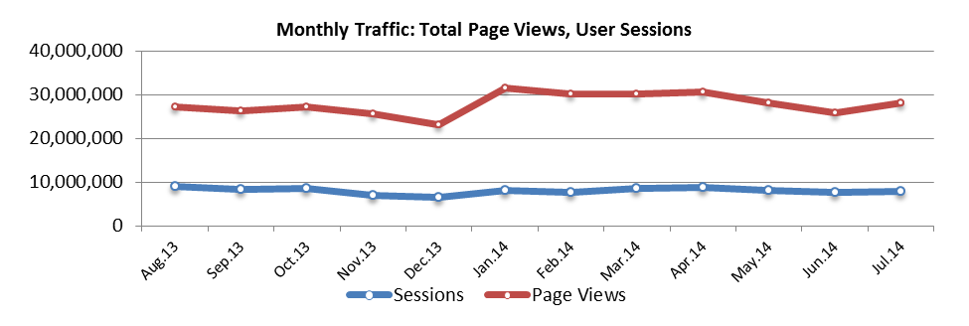
► Forms, E-Verify and Green Card Landing Pages Attract Highest Traffic
The Forms, E-Verify and Green Card landing pages drew the most traffic. Traffic increased an average of 8.45% compared to last month. Page views of the Forms landing page increased 1.82%. Traffic to the News page decreased 6.14%. Traffic to the Green Card page increased 6.73%. (See Page 2)
► Customer Satisfaction Scores This Month
The score for USCIS-ES.gov increased from 83 to 86 this month with 120 respondents. The score for USCIS.gov remained at 75 with 1,153 respondents this month. (See page 10.)
USCIS | USCIS-ES | Federal Govt.
75 | 86 | 72
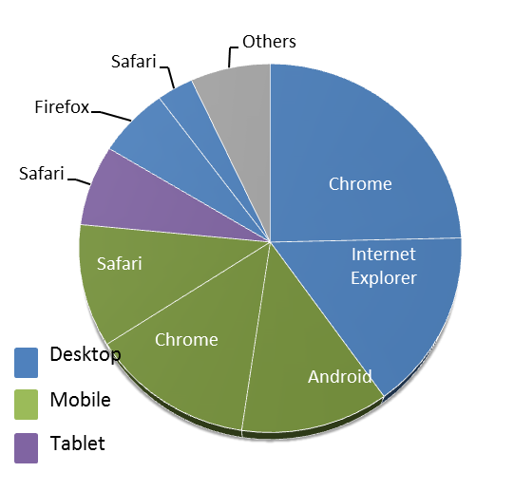
► USCIS-ES Site Traffic by Desktop, Mobile and Tablet Browsers
Mobile traffic accounts for roughly one third of Spanish Site usage. Compared to last month, User Sessions by Windows Desktop browsers decreased 0.23% while Android Mobile User Sessions increased 5.54%. (See page 14.)

CSWP Visitor Traffic
► Notable changes this month: The primary Visitor Traffic Metrics tools have changed from a web log-based tool to Google Analytics, and the metric categories have changed accordingly so trend data is not comparable between April and May. Comparing Google Analytics data between June and July however, page views increased 8.45% over last month. User Sessions increased 3.75%. Page views of PDFs decreased 1.31%.
Metric | Apr.14 | Google Analytics Metrics | May.14 | Jun.14 | Jul.14 | Change
Overall
Page Views | 30,468,354 | Pageviews | 28,195,095 | 25,903,311 | 28,090,994 | 8.45%
Unique Visitors | 6,753,631 | Users | 4,250,226 | 3,963,054 | 4,123,915 | 4.06%
User Sessions (Visits) | 13,378,783 | Sessions | 8,154,773 | 7,689,791 | 7,977,963 | 3.75%
Avg. Session Length (min.) | 3:51 | Avg Session Duration | 00:04:04 | 00:04:08 | 00:04:11 | 1.21%
Avg. Weekday User Sessions | 513,241 | % New Sessions | 40.38% | 39.70% | 40.22% | 1.31%
One-Time Visitors | 4,797,692 | Pageviews/Session | 3.46 | 3.37 | 3.52 | 4.45%
Repeat Visitors | 1,955,939 | Bounce Rate | 51.96% | 51.64% | 51.67% | 0.06%
Page Views & Documents Hit | 58,158,678 | PDF Pageviews* | 23,725,023 | 19,984,303 | 19,722,465 | -1.31%
* PDF pageviews represent the number of views of files with the .PDF extension, as tracked in web logs (not Google Analytics).
Distribution of Traffic by Major Landing Pages
The CSWP Home Page makes it easy for visitors to find and navigate to popular information and resources. The table and chart below reflect counts of user sessions to 15 key landing pages.
► Notable changes this month: The Forms, E-Verify and Green Card landing pages drew the most traffic. Traffic increased an average of 8.45% compared to last month. Page views of the Forms landing page increased 1.82%. Traffic to the News page decreased 6.14%. Traffic to the Green Card page increased 6.73%.
 | Page | Page  Views | Unique Pageviews | Avg. Time on Page | Entrances* | Bounce Rate | % Exit
1 | /forms | 1,128,899 | 756,847 | 56.5 | 272,665 | 20.02% | 12.62%
2 | /e-verify | 327,411 | 253,585 | 96.8 | 217,676 | 61.88% | 54.10%
3 | /greencard | 319,194 | 227,460 | 49.3 | 91,869 | 22.93% | 15.06%
4 | /us-citizenship | 179,167 | 127,494 | 71.4 | 58,375 | 29.89% | 19.60%
5 | /news | 99,403 | 80,191 | 66.1 | 32,518 | 44.56% | 30.86%
6 | /tools | 76,513 | 53,027 | 106.7 | 10,236 | 59.70% | 37.94%
7 | /aboutus | 66,075 | 53,276 | 67.6 | 15,370 | 37.35% | 23.41%
8 | /laws | 48,529 | 38,993 | 74.1 | 14,771 | 42.07% | 27.28%
9 | /working-united-states/working-us | 35,486 | 29,633 | 97.6 | 13,655 | 41.90% | 29.72%
10 | /family | 29,621 | 22,629 | 49.7 | 1,944 | 29.37% | 10.09%
11 | /visit-united-states/visit-us | 23,233 | 17,281 | 146.4 | 5,377 | 59.42% | 42.64%
12 | /outreach | 15,784 | 13,698 | 93.2 | 5,768 | 44.85% | 33.48%
13 | /adoption | 13,860 | 9,781 | 71.9 | 2,811 | 34.83% | 18.69%
14 | /military | 11,775 | 8,971 | 96.8 | 2,046 | 43.79% | 21.69%
15 | /humanitarian | 9,730 | 7,616 | 72.1 | 1,662 | 36.04% | 17.27%

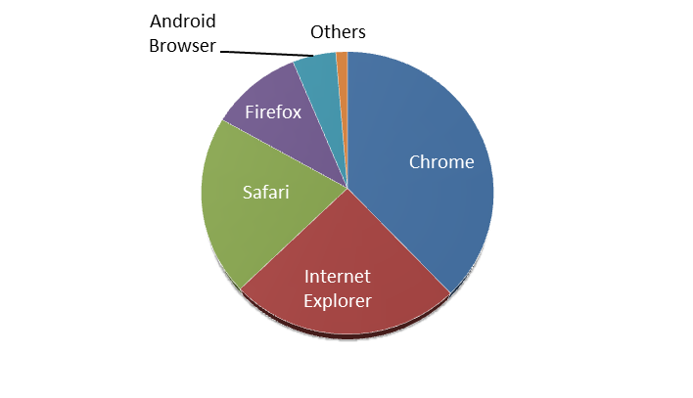
Top 25 Browser Versions Used by Visitors to USCIS.gov
The following table shows the browsers most frequently used by visitors to the USCIS Customer Service Web Portal (CSWP) at USCIS.gov.
► Notable changes this month: Site traffic by all browsers increased 3.75% over last month. Site traffic by Chrome browsers increased 5.50%. Site traffic by Internet Explorer browsers increased 0.91%. Site traffic by Safari browsers increased 5.59%.
Browser | Browser Version | Sessions | Pages / Session | Avg. Visit Duration
Chrome | 35.0.1916.153 | 1,306,897 | 3.62 | 4:17
Safari | 7.0 | 1,001,537 | 2.99 | 3:07
Internet Explorer | 11.0 | 885,580 | 3.90 | 5:07
Chrome | 36.0.1985.125 | 789,246 | 3.43 | 4:16
Firefox | 30.0 | 611,421 | 3.57 | 4:24
Internet Explorer | 8.0 | 395,188 | 3.73 | 5:07
Android Browser | 4.0 | 388,357 | 3.32 | 3:40
Internet Explorer | 9.0 | 333,645 | 3.74 | 4:23
Internet Explorer | 10.0 | 295,896 | 3.82 | 4:46
Chrome | 35.0.1916.141 | 194,485 | 3.59 | 3:17
Chrome | 1.5 | 132,384 | 3.15 | 3:03
Safari | 7.0.5 | 125,397 | 3.62 | 4:20
Firefox | 31.0 | 82,124 | 3.26 | 4:10
Safari | 6.0 | 73,770 | 3.19 | 3:24
Safari | 9537.53 | 68,989 | 3.61 | 3:45
Safari | 7.0.4 | 67,644 | 4.09 | 4:30
Chrome | 36.0.1985.128 | 63,369 | 3.03 | 3:07
Internet Explorer | 7.0 | 60,238 | 3.29 | 3:54
Safari | 5.1.9 | 51,148 | 4.01 | 4:37
Safari | 7.0.3 | 39,645 | 3.94 | 4:37
Chrome | 35.0.1916.114 | 39,333 | 3.61 | 4:33
Chrome | 1.6 | 37,804 | 3.15 | 3:14
Safari (in-app) | (not set) | 34,448 | 4.72 | 2:36
Chrome | 35.0.1916.41 | 26,595 | 3.32 | 3:32
Firefox | 29.0 | 25,612 | 3.72 | 4:32

FOIA Status Check
The tables on this page reflect traffic to the FOIA Status Check landing page and the number of transactions submitted to the application.
► Notable changes this month: Page views decreased 5.24% and Transactions increased 15.44%.

 | Oct.13 | Nov.13 | Dec.13 | Jan.14 | Feb.14 | Mar.14 | Apr.14 | May.14 | Jun.14 | Jul.14
Page Views on Landing Page | 22,479 | 7,303 | 9,507 | 13,861 | 19,317 | 22,744 | 22,164 | 20,058 | 18,453 | 17,486
– Transactions | 14,302 | 13,171 | 14,009 | 13,927 | 13,623 | 17,244 | 14,993 | 15,220 | 15,743 | 18,174

 | Dec.12 | Jan.13 | Feb.13 | Apr.13 | Mar.13 | May.13 | Jun.13 | Jul.13 | Aug.13 | Sep.13
Page Views on Landing Page | 18,708 | 23,753 | 20,934 | 23,826 | 23,837 | 24,159 | 22,688 | 24,485 | 25,326 | 23,587
– Transactions | 11,448 | 13,081 | 10,930 | 13,627 | 13,751 | 14,711 | 13,457 | 15,341 | 16,456 | 14,329

 | Feb.12 | Mar.12 | Apr.12 | May12 | Jun.12 | Jul.12 | Aug.12 | Sep.12 | Oct.12 | Nov.12
Page Views on Landing Page | 27,787 | 30,585 | 29,569 | 29,543 | 30,274 | 32,278 | 33,968 | 26,182 | 25,379 | 22,656
– Transactions | 20,882 | 23,919 | 22,893 | 23,525 | 22,939 | 23,731 | 26,136 | 18,187 | 17,008 | 14,421

 | Apr.11 | May11 | June11 | July11 | Aug.11 | Sep.11 | Oct.11 | Nov.11 | Dec.11 | Jan.12
Page Views on Landing Page | 24,183 | 32,553 | 36,238 | 29,879 | 29,076 | 26,112 | 25,260 | 29,930 | 28,005 | 32,342
– Transactions | 19,472 | 22,862 | 25,464 | 21,749 | 21,772 | 20,002 | 19,672 | 19,777 | 21,375 | 25,048

 | June10 | July10 | Aug.10 | Sep.10 | Oct.10 | Nov.10 | Dec.10 | Jan.11 | Feb.11 | Mar.11
Page Views on Landing Page | 26,338 | 33,403 | 37,913 | 35,005 | 24,986 | 19,561 | 18,296 | 22,190 | 22,562 | 27,118
– Transactions | 16,521 | 19,017 | 22,584 | 21,597 | 16,757 | 13,696 | 13,401 | 15,828 | 17,096 | 21,085

 | Aug.09 | Sep.09 | Oct.09 | Nov.09 | Dec.09 | Jan.10 | Feb.10 | Mar.10 | Apr.10 | May10
Page Views on Landing Page | 18,562 | 15,861 | 14,056 | 17,725 | 28,414 | 30,624 | 27,712 | 29,196 | 26,796 | 27,990
– Transactions | 16,442 | 12,222 | 12,397 | 14,984 | 16,994 | 19,228 | 14,888 | 16,721 | 17,887 | 18,565
 | Oct.08 | Nov.08 | Dec.08 | Jan.09 | Feb.09 | Mar.09 | Apr.09 | May09 | June09 | July09
Page Views on Landing Page | 11,277 | 9,996 | 10,174 | 11,946 | 11,804 | 13,543 | 14,598 | 15,717 | 17,664 | 27,387
– Transactions | 11,783 | 10,536 | 10,477 | 12,398 | 11,808 | 13,543 | 14,787 | 13,991 | 16,170 | 12,214

Top 25 Viewed Pages
The following table shows the 25 most viewed pages on USCIS.gov with additional statistics according to Google Analytics.
► Notable changes this month: Page Views increased an average of 8.45%. Page Views of the USCIS Homepage increased 1.1%. Page Views of the “Forms” page increased 2.07%. Page Views of the “Naturalization Self-Test” page increased 54.29%. Page Views of the “Petition for Alien Relative” increased 5.20%. Page Views of “Consideration of Deferred Action for Childhood Arrivals” decreased 21.54%
 | Page Title | Page  Views | Unique Pageviews | Avg. Time on Page | Entrances* | Bounce Rate
1 | Homepage | 4,695,619 | 3,621,704 | 2:08 | 3,377,396 | 54.16%
2 | Naturalization Self-Test 1 | 3,012,428 | 202,252 | 0:16 | 89,273 | 19.51%
3 | Forms | 1,352,104 | 931,775 | 0:56 | 279,314 | 20.43%
4 | Naturalization Self-Test 2 | 1,101,145 | 56,596 | 0:17 | 7,850 | 32.51%
5 | Application for Naturalization | 638,569 | 351,081 | 3:20 | 120,747 | 55.38%
6 | Petition for Alien Relative | 591,783 | 332,628 | 3:07 | 109,854 | 48.18%
7 | Naturalization Self-Test 3 | 548,104 | 27,057 | 0:16 | 3,279 | 30.13%
8 | Application for Employment Authorization | 392,933 | 215,869 | 2:53 | 66,325 | 44.72%
9 | Application to Register Permanent Residence or Adjust Status | 365,273 | 218,331 | 2:46 | 51,343 | 45.76%
10 | 100 Civics Questions and Answers with MP3 Audio (English version) | 341,053 | 118,608 | 2:05 | 90,658 | 69.42%
11 | Application to Replace Permanent Resident Card | 332,124 | 185,482 | 3:21 | 56,938 | 47.74%
12 | E-Verify | 331,871 | 257,148 | 1:36 | 218,936 | 61.79%
13 | Affidavit of Support Under Section 213A of the Act | 328,140 | 198,049 | 3:50 | 70,820 | 50.74%
14 | Green Card | 319,354 | 227,576 | 0:49 | 91,928 | 22.93%
15 | Espanol Homepage | 292,259 | 192,020 | 1:59 | 77,384 | 51.49%
16 | Consideration of Deferred Action for Childhood Arrivals | 219,032 | 102,448 | 3:17 | 25,675 | 44.90%
17 | Employment Eligibility Verification | 216,141 | 161,586 | 2:03 | 112,163 | 74.64%
18 | Apply for Citizenship | 210,466 | 154,807 | 1:33 | 47,456 | 28.50%
19 | Green Card Through Family | 192,777 | 145,859 | 0:53 | 10,544 | 33.04%
20 | USCIS ELIS | 189,034 | 130,494 | 4:01 | 81,592 | 63.27%
21 | Instructions for Electronic Filing of Form I-90 (Renew or Replace a Green Card Online) | 185,065 | 113,756 | 2:44 | 14,286 | 50.94%
22 | Application for Travel Document | 181,821 | 109,436 | 3:20 | 40,165 | 48.46%
23 | U.S. Citizenship | 179,525 | 127,797 | 1:12 | 58,426 | 29.92%
24 | Contact Us | 177,396 | 133,985 | 2:39 | 64,540 | 53.40%
25 | Renew a Green Card | 173,110 | 120,458 | 1:22 | 51,838 | 24.90%
* “Entrances” count the first hit of the session that is also a page.

Top 25 PDF Page Views
The following table shows the 25 most viewed PDFs on USCIS.gov.
► Notable changes this month: Total PDF Page Views decreased 1.31%, from 19.98 million in June to 19.7 million in July. The “A4en.pdf” was downloaded 511,969 times, up 88.31% from last month. The i-589 was up 597.31% from 52,398 in June to 365,377 in July. The most downloaded file this month was the “i-9.pdf” with 3.49 million downloads, 8.90% fewer than last month. The “i-765.pdf” was the second most downloaded file, down 10.75% over last month.
 | Top 25 Downloaded Files | Page Views | % of Total  All Hits
1 | files/form/i-9.pdf | 3,490,422 | 17.70%
2 | files/form/i-765.pdf | 1,429,186 | 7.25%
3 | files/form/m-274.pdf | 1,000,359 | 5.07%
4 | files/form/n-400.pdf | 618,275 | 3.13%
5 | USCIS/Resources/A4en.pdf | 511,969 | 2.60%
6 | files/form/n-400instr.pdf | 469,356 | 2.38%
7 | files/form/i-90instr.pdf | 397,786 | 2.02%
8 | USCIS/Verification/E-Verify/E-Verify_Native_Documents/E-Verify%20Manuals%20and%20Guides/EVerify_User_Manual_Employer.pdf | 378,586 | 1.92%
9 | files/form/i-589.pdf | 365,377 | 1.85%
10 | files/form/i-765instr.pdf | 360,700 | 1.83%
11 | files/form/i-864instr.pdf | 358,079 | 1.82%
12 | uscis.cgi.dhs.akadns.net/files/form/i-9.pdf | 288,978 | 1.47%
13 | files/form/g-1055.pdf | 286,759 | 1.45%
14 | files/form/i-129.pdf | 284,651 | 1.44%
15 | files/form/i-864.pdf | 275,636 | 1.40%
16 | files/form/g-1145.pdf | 274,901 | 1.39%
17 | files/form/i-765ws.pdf | 244,984 | 1.24%
18 | files/form/i-130.pdf | 235,078 | 1.19%
19 | files/form/i-90.pdf | 230,755 | 1.17%
20 | files/article/attachments.pdf | 206,275 | 1.05%
21 | files/form/i-485instr.pdf | 200,545 | 1.02%
22 | files/form/i-130instr.pdf | 195,981 | 0.99%
23 | USCIS/Verification/E-Verify/E-Verify%20from%20Controlled%20Vocabulary/E-VerifyFedContrListandQueryVol.pdf | 193,596 | 0.98%
24 | USCIS/Office%20of%20Citizenship/Citizenship%20Resource%20Center%20Site/Publications/PDFs/M-638_red.pdf | 190,335 | 0.97%
25 | files/form/i-131instr.pdf | 174,644 | 0.89%
Total Downloaded Files this Month > |  | 19,722,465 | 100.00%

Top 25 Referring Sites Sending Traffic to CSWP
The following table lists the top 25 sources of Web traffic referred to USCIS.gov from external Web sites.
► Notable changes this month: Sessions referred from all sites increased an average of 0.10%. Sessions referred from travel.state.gov decreased 0.74%. Sessions referred from usa.gov increased 14.80%. Sessions referred from m.facebook.com decreased 18.20%.
 | Search Term | Sessions | % New Sessions* | Bounce Rate** | Pages / Visit | Avg. Visit Duration
1 | travel.state.gov | 140,946 | 34.80% | 44.43% | 3.17 | 5:33
2 | search.uscis.gov | 123,754 | 1.91% | 45.43% | 3.19 | 5:28
3 | dhs.gov | 32,449 | 55.33% | 46.82% | 3.72 | 4:21
4 | links.govdelivery.com | 24,294 | 18.06% | 46.93% | 2.99 | 4:12
5 | uscis.gov | 20,367 | 53.04% | 21.04% | 3.22 | 2:24
6 | usa.gov | 16,730 | 65.71% | 35.40% | 4.91 | 6:13
7 | ustraveldocs.com | 16,246 | 50.20% | 52.41% | 2.92 | 4:30
8 | search.dhs.gov | 15,942 | 50.36% | 42.75% | 3.72 | 4:57
9 | visajourney.com | 13,465 | 18.31% | 65.07% | 2.27 | 3:13
10 | m.facebook.com | 12,677 | 73.57% | 57.58% | 6.74 | 2:51
11 | nolo.com | 9,548 | 42.38% | 53.74% | 2.71 | 3:41
12 | trackitt.com | 9,285 | 16.88% | 77.76% | 1.59 | 1:50
13 | search.tb.ask.com | 8,279 | 32.12% | 40.85% | 4.02 | 6:10
14 | facebook.com | 8,013 | 40.18% | 51.52% | 7.44 | 4:34
15 | dashboard.uscis.gov | 7,251 | 14.09% | 54.97% | 2.89 | 3:43
16 | us.wow.com | 6,905 | 40.65% | 46.30% | 4.89 | 4:48
17 | immihelp.com | 5,588 | 32.80% | 55.06% | 2.77 | 3:45
18 | en.wikipedia.org | 4,943 | 58.24% | 54.78% | 3.05 | 3:24
19 | uscitizenpod.com | 4,065 | 23.99% | 48.51% | 4.46 | 8:40
20 | l.facebook.com | 3,886 | 50.05% | 48.82% | 11.54 | 4:46
21 | ambals.blogspot.com | 3,815 | 34.97% | 80.42% | 1.48 | 1:15
22 | search.usa.gov | 3,651 | 49.06% | 38.29% | 4.76 | 6:55
23 | visabureau.com | 3,618 | 84.60% | 32.20% | 3.86 | 3:04
24 | apps.irs.gov | 3,489 | 73.77% | 72.43% | 1.67 | 1:15
25 | adoption.state.gov | 3,430 | 52.16% | 53.03% | 2.87 | 4:01
* New Sessions is the percentage the pages that were viewed by first time visitors.
**Bounce rate is the percentage of pages that were viewed once followed by an exit.

Top 25 Search Terms from Referring External Search Engines
The following are the top 25 search terms entered into external search engines (e.g., Google, Yahoo, Bing, and others) that led to referrals of Web traffic to the CSWP. This list does not include search terms that resulted in PDFs.
►Notable changes this month: Searches increased 5.55% over last month. Searches of “uscis” decreased 6.93% over last month. Searches of “uscis case status” decreased 17.63% over last month. Searches for “e-verify” increased 22.79%.
 | Source / Medium | Sessions | % New Sessions* | Bounce Rate** | Pages / Visit | Avg. Visit Duration
1 | (not provided) | 3,898,368 | 36.51% | 1,423,325 | 49.54% | 3.72
2 | uscis | 107,919 | 25.71% | 27,747 | 42.99% | 3.78
3 | uscis.gov | 36,975 | 22.80% | 8,429 | 38.04% | 4.15
4 | www.uscis.gov | 27,264 | 24.03% | 6,551 | 42.69% | 3.91
5 | uscis case status | 15,684 | 15.02% | 2,355 | 66.31% | 2.15
6 | uscis forms | 10,537 | 24.07% | 2,536 | 23.75% | 4.07
7 | http://www.uscis.gov/ | 10,040 | 9.50% | 954 | 59.97% | 2.76
8 | everify | 7,627 | 30.63% | 2,336 | 64.17% | 2.31
9 | http://uscis.gov/ | 6,382 | 16.64% | 1,062 | 50.28% | 3.39
10 | immigration | 6,254 | 41.85% | 2,617 | 41.61% | 4.08
11 | e-verify | 6,045 | 36.63% | 2,214 | 55.67% | 2.80
12 | ins | 5,487 | 46.91% | 2,574 | 35.81% | 4.59
13 | us immigration | 3,844 | 49.14% | 1,889 | 32.28% | 5.01
14 | uscis elis | 3,831 | 18.32% | 702 | 61.37% | 2.35
15 | e verify | 3,562 | 33.16% | 1,181 | 61.23% | 2.49
16 | 美国移民局 | 3,425 | 41.43% | 1,419 | 52.35% | 3.14
17 | i9 | 3,124 | 63.25% | 1,976 | 79.87% | 1.49
18 | uscis.gov forms | 3,045 | 26.01% | 792 | 26.80% | 4.04
19 | i-9 form | 3,044 | 64.75% | 1,971 | 77.50% | 1.54
20 | website www uscis gov | 2,851 | 36.23% | 1,033 | 43.81% | 3.80
21 | green card | 2,564 | 60.22% | 1,544 | 34.13% | 4.28
22 | citizenship test | 2,526 | 39.23% | 991 | 38.12% | 20.83
23 | www.uscis.gov/uscis-elis | 2,411 | 28.45% | 686 | 45.38% | 3.48
24 | green card renewal | 2,301 | 45.42% | 1,045 | 27.21% | 4.25
25 | us citizenship and immigration services uscis | 2,158 | 39.67% | 856 | 39.16% | 5.48

Top 50 Search Terms Entered into the CSWP Search Engine
The top search terms entered into the CSWP main site's internal search engine indicate what is most important to CSWP visitors once they enter the site.
►Notable changes this month: Total queries decreased 6.56% from 1,276,073 in June to 1,192,413 in July. Searches for “case status” decreased 11.96%. Searches for “g-325a” increased 13.99%. Searches for “i-765” increased 6.50%. Searches for “i-821d” decreased 19.15%.

Search Term | Count
case status | 16,445
check status of my case | 9,311
status of my case | 9,116
what are you looking for? | 8,705
i-864 | 7,760
i-765 | 7,721
i-130 | 7,344
my case status | 7,337
case status check online | 7,184
daca | 6,865
processing times | 6,285
change of address online | 6,068
g-325a | 5,591
i-485 | 5,512
status | 5,190
i-131 | 4,431
infopass | 4,275
change of address | 4,099
n-400 | 4,037
i-90 | 4,034
elis | 3,741
infopass make appointment | 3,581
visa bulletin | 3,526
n400 | 3,366
i130 | 3,341
i765 | 3,289
i-751 | 3,280
i864 | 3,253
daca renewal 2014 application | 3,203
i-821d | 3,175
my case status check online | 2,958
visa bulletin august 2014 | 2,934
g325a | 2,866
i-94 | 2,849
case status by receipt number | 2,815
civil surgeon locator | 2,725
i-912 | 2,575
i485 | 2,471
check status | 2,410
poverty guidelines 2014 | 2,321
i-864a | 2,300
visa | 2,244
g-28 | 2,237
status of my application | 2,199
i-693 | 2,141
opt | 2,126
opt status check | 2,122
g-325a form | 2,107
i90 | 2,104
fee waiver | 2,100


Surveys of User Satisfaction
USCIS.gov and its Spanish language area, USCIS-ES, use ForeSee Results surveys, part of the American Customer Satisfaction Index (ACSI) E-Government Index, to gauge customer satisfaction and identify areas for improvement.
►Notable changes this month: The score for USCIS-ES.gov increased from 83 to 86 this month with 120 respondents this month. The score for USCIS.gov remained at 75 with 1,153 respondents this month.
This Month's Average Customer Satisfaction Scores
USCIS | USCIS-ES | Federal Govt.
75 | 86 | 72
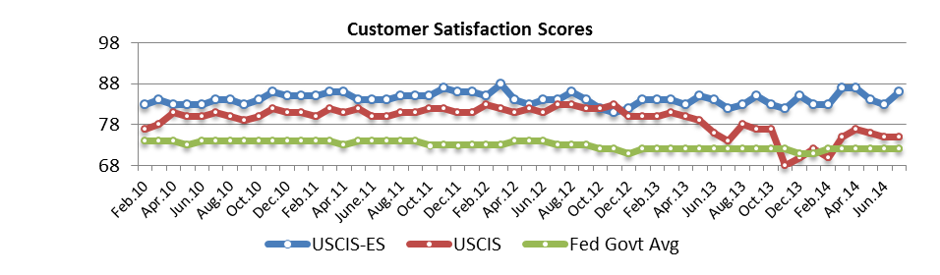
Top Visitor Responses to Selected Survey Questions (% of respondents per site)
Primary Reason for Visiting the Site | USCIS | USCIS-ES
Check My Case Status | 17% | 20%
Green Card Information | 14% | 14%
Download Form(s) | 11% | 5%
Find Form(s) | 13% | 6%
Get General Information Before I File My Case | 11% | 18%
Citizenship Requirements | 3% | 6%
Primary Method Used to Find Information
Links on the pages | 25% | 19%
Site's Search Feature | 23% | 28%
Top Navigation Bar | 17% | 21%
Forms search | 13% | N/A
Used an External Search Engine (e.g., Google) | 10% | 10%
Homepage banners, icons, ads | 6% | 4%
Just Browsing | 5% | 14%
Site Map | 1% | 4%
Self-Identified Role of Visitor
Permanent Resident (green card holder) | 22% | 29%
Naturalized U.S. Citizen | 19% | 14%
U.S. Born Citizen | 19% | 2%
Citizen of a Foreign Country | 9% | 15%
Visitor/Nonimmigrant | 5% | 17%

Social Media Activity Using Links
on CSWP Pages
Many CSWP pages offer social media options. By taking one of these actions, visitors can share a page or bookmark it using a variety of social media tools. In previous months, Social Media Activity from the Citizenship Resource Center (CRC) was combined with all other Activity. This month it is being separated. See the next page for the CRC report on Social Media Activity.
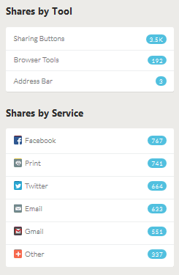
►Notable changes this month: Facebook was the top sharing service this month with 767 shares, followed by Print with 741 shares. The “Application for Naturalization” page was shared 81 and clicked 83 times.
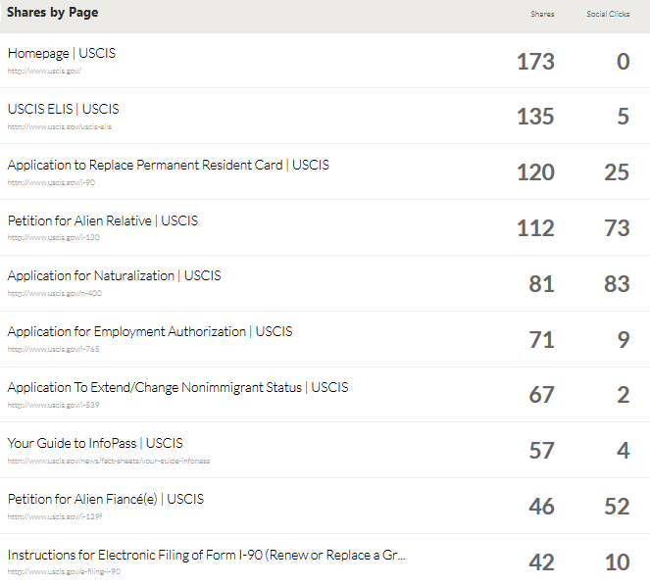
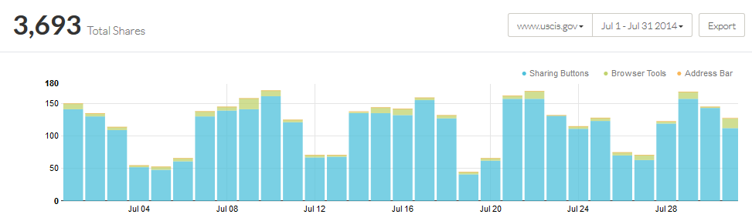

Social Media Activity Using Links
on Citizenship Resource Center Pages
Many CSWP pages offer social media options. By taking one of these actions, visitors can share a page or bookmark it using a variety of social media tools.
►Notable changes this month: Facebook was the top sharing service this month with 2,300 shares. The “Naturalization Self-Test” was the most shared.
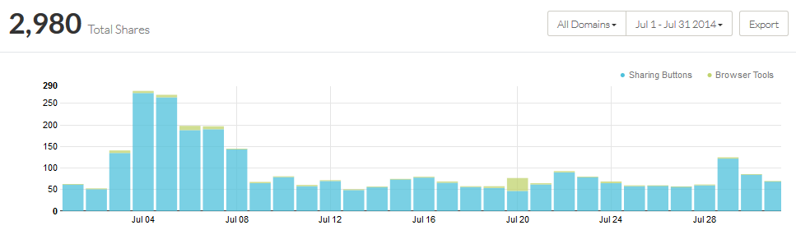
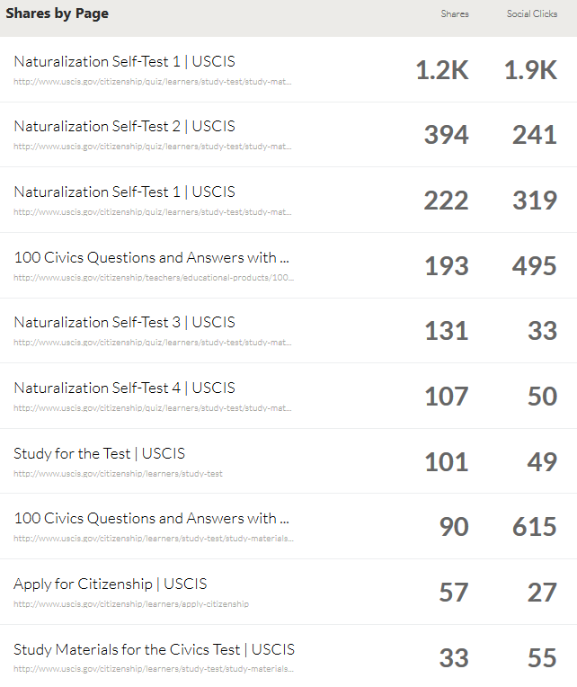
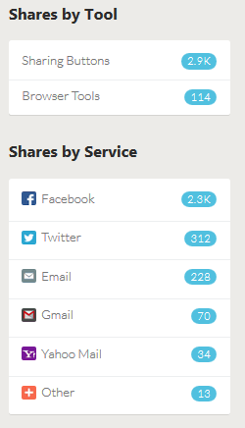

Subscription Email Messages and Tweets
Visitors to USCIS.gov may subscribe to several of the site's topic areas so they can be sent email bulletins when content changes. Subscriptions are initiated by visitors using the right-column news widget or the Get Email Updates link on many pages. The most subscribed topics are News, Forms, H-1B Cap Season, Federal Register Announcements, and E-Verify Updates. People may also follow USCIS.gov using Twitter.
►Notable changes this month: USCIS distributed 2,187,720 email bulletins to subscribers, 39.54% more than the previous month. Tweets increased from 43 to 63. Twitter followers increased 3.44% over last month.

 | Jan.14 | Feb.14 | Mar.14 | Apr.14 | May.14 | Jun.14 | Jul.14
GovDelivery Emails Issued | 17 | 16 | 28 | 28 | 19 | 21 | 23
Emails Distributed to Subscribers | 1,214,810 | 997,583 | 1,872,711 | 2,634,479 | 1,897,736 | 1,567,847 | 2,187,720
Subscribers at End of Month | 403,424 | 405,252 | 406,632 | 408,500 | 405,497 | 407,621 | 417,934
Subscriptions | 1,243,034 | 1,250,826 | 1,258,551 | 1,268,668 | 1,262,430 | 1,267,153 | 1,282,317
Total Subscribable Topics | 56 | 58 | 58 | 58 | 58 | 57 | 58
Tweets Issued | 95 | 96 | 87 | 47 | 45 | 43 | 63
Twitter Followers at End of Month | 33,400 | 34,057 | 35,297 | 36,925 | 38,484 | 39,383 | 40,738

 | Jun.13 | Jul.13 | Aug.13 | Sep.13 | Oct.13 | Nov.13 | Dec.13
GovDelivery Emails Issued | 23 | 27 | 19 | 17 | 22 | 22 | 18
Emails Distributed to Subscribers | 1,663,637 | 2,031,262 | 911,515 | 1,516,924 | 1,657,058 | 2,333,107 | 1,719,876
Subscribers at End of Month | 391,206 | 399,076 | 401,420 | 403,834 | 402,895 | 401,817 | 401,575
Subscriptions | 1,188,393 | 1,207,556 | 1,221,140 | 1,234,000 | 1,238,863 | 1,237,090 | 1,238,296
Total Subscribable Topics | 52 | 52 | 52 | 54 | 54 | 55 | 55
Tweets Issued | 71 | 55 | 40 | 78 | 74 | 38 | 67
Twitter Followers at End of Month | 27,022 | 28,026 | 28,910 | 29,890 | 30,747 | 31,275 | 32,182

 | Nov.12 | Dec.12 | Jan.13 | Feb.13 | Mar.13 | Apr.13 | May.13
GovDelivery Emails Issued | 21 | 20 | 27 | 26 | 38 | 31 | 23
Emails Distributed to Subscribers | 1,178,514 | 1,205,772 | 976,597 | 1,958,689 | 2,457,203 | 2,976,849 | 2,079,216
Subscribers at End of Month | 351,251 | 352,647 | 350,708 | 351,570 | 355,875 | 388,352 | 389,453
Subscriptions | 1,076,205 | 1,085,296 | 1,099,382 | 1,108,975 | 1,127,188 | 1,175,533 | 1,175,771
Total Subscribable Topics | 45 | 45 | 46 | 46 | 48 | 50 | 52
Tweets Issued | 83 | 28 | 48 | 115 | 37 | 84 | 22
Twitter Followers at End of Month | 19,308 | 20,097 | 20,932 | 21,769 | 22,606 | 25,461 | 26,250

 | Apr.12 | May12 | Jun.12 | Jul.12 | Aug.12 | Sep.12 | Oct.12
GovDelivery Emails Issued | 25 | 23 | 21 | 21 | 32 | 17 | 21
Emails Distributed to Subscribers | 1,611,791 | 1,964,307 | 1,884,932 | 1,544,738 | 1,756,493 | 990,637 | 1,854,492
Subscribers at End of Month | 334,004 | 336,238 | 331,965 | 334,609 | 340,036 | 344,324 | 346,798
Subscriptions | 999,404 | 1,008,018 | 1,003,501 | 1,007,796 | 1,031,839 | 1,047,022 | 1,061,009
Total Subscribable Topics | 23 | 23 | 23 | 28 | 44 | 44 | 45
Tweets Issued | 118 | 143 | 185 | 90 | 57 | 38 | 127
Twitter Followers at End of Month | 13,591 | 14,320 | 15,209 | 15,765 | 17,457 | 18,000 | 18,688

USCIS-ES Visitor Traffic
The CSWP includes USCIS-ES, a Spanish language version of many of its pages. Since its launch in late 2009, USCIS-ES has regularly accounted for about 3% of all traffic to the CSWP.
► Notable changes this month: The primary Visitor Traffic Metrics tools have changed from a web log-based tool to Google Analytics, and the metric categories have changed accordingly so trend data is not comparable between April and May. Comparing Google Analytics data between June and July however, User Sessions and Page Views increased 3.02% and 3.42% respectively.
Metric | Mar.14 | Apr.14 | Google Analytics Metrics | May.14 | Jun.14 | Jul.14
Overall
Page Views | 1,086,537 | 1,038,839 | Pageviews | 1,130,829 | 1,050,509 | 1,086,402
Unique Visitors | 317,456 | 303,720 | Users | 210,549 | 228,648 | 228,881
User Sessions (Visits) | 503,973 | 477,879 | Sessions | 366,773 | 347,080 | 357,563
Avg. Session Length (min.) | 3:11 | 3:16 | Avg Session Duration | 0:04:34 | 00:04:13 | 00:04:18
Avg. Weekday User Sessions | 18,599 | 17,881 | % New Sessions | 45.04% | 62.73% | 57.31%
One-Time Visitors | 234,215 | 225,626 | Pageviews/Session | 3.08 | 3.03 | 3.04
Repeat Visitors | 83,241 | 78,094 | Bounce Rate | 52.03% | 52.49% | 52.23%

USCIS-ES Site Traffic by Desktop, Mobile and Tablet Browsers
The following table and accompanying pie chart shows the browsers by operating system and device category that most frequently use the USCIS-ES Spanish.
► Notable changes this month: Mobile traffic accounts for roughly one third of Spanish Site usage. Compared to last month, User Sessions by Windows Desktop browsers decreased 0.23% while Android Mobile User Sessions increased only 5.54%.
OS (device category) | Jun.14 | Jul.14 | Change
Windows (desktop) | 161,015 | 160,640 | -0.23%
Android (mobile) | 86,604 | 91,401 | 5.54%
iOS (mobile) | 38,687 | 40,655 | 5.09%
iOS (tablet) | 27,346 | 27,604 | 0.94%
Macintosh (desktop) | 14,302 | 15,244 | 6.59%
Android (tablet) | 10,820 | 11,100 | 2.59%
Windows (mobile) | N/A | 3,278 | N/A
Windows Phone (mobile) | 1,961 | 2,117 | 7.96%
BlackBerry (mobile) | 1,309 | 1,470 | 12.30%
Linux (desktop) | 1,238 | 1,293 | 4.44%
Total | 347081 | 357,563 | 3.02%

Top 25 Viewed USCIS-ES Pages
The following table shows the 25 most viewed pages on USCIS-ES this month with additional statistics according to Google Analytics.
► Notable changes this month: Page Views were down an average of 3.42%. The USCIS-ES homepage was viewed 291,254 times in July compared to 291,229 times in June, an increase of 0.01%. Page Views of the “Formularios” page were up 4.11% from last month. Page Views of the “Petición de Familiar Extranjero” page were up 9.04% from last month. Page Views of the “Trámite y procedimientos para la Tarjeta Verde” page were up 11.48% over last month.
 | Page Title | Page  Views | Unique Pageviews | Avg. Time on Page | Entrances* | % Exit**
1 | Espanol Homepage | 291,254 | 191,907 | 2:12 | 182,141 | 45.78%
2 | Formularios | 50,108 | 32,383 | 1:13 | 6,302 | 13.65%
3 | Petición de Familiar Extranjero | 27,319 | 16,018 | 2:53 | 4,682 | 31.25%
4 | Trámite y procedimientos para la Tarjeta Verde | 24,571 | 16,656 | 1:32 | 5,835 | 21.61%
5 | Tarjeta Verde | 21,239 | 13,921 | 0:51 | 2,905 | 12.25%
6 | Tarjeta Verde a través de la Familia | 17,464 | 12,062 | 1:02 | 620 | 10.17%
7 | El examen de naturalización: Materiales de estudio | 16,243 | 10,243 | 2:31 | 4,915 | 38.62%
8 | Consideración de Acción Diferida para los Llegados en la Infancia | 15,743 | 10,382 | 2:49 | 6,319 | 41.47%
9 | Solicitud de Naturalización | 14,686 | 8,493 | 3:15 | 3,984 | 39.69%
10 | Solicitud de Registro de Residencia Permanente o Ajuste de Estatus | 14,609 | 9,872 | 2:56 | 2,939 | 32.04%
11 | Noticias | 14,485 | 11,270 | 1:07 | 734 | 15.80%
12 | Ciudadanía | 13,305 | 9,013 | 1:14 | 2,100 | 18.92%
13 | Mientras mi caso está en trámite con el USCIS | 12,488 | 9,156 | 3:16 | 4,661 | 40.91%
14 | Solicitud para Reemplazar la Tarjeta de Residente Permanente (Green Card) | 12,443 | 6,543 | 3:11 | 2,320 | 34.85%
15 | Contáctenos | 12,268 | 8,268 | 2:32 | 1,936 | 34.24%
16 | Familiares de Ciudadanos Estadounidenses | 11,781 | 7,719 | 2:09 | 3,094 | 23.44%
17 | Preguntas y Respuestas sobre temas relacionados a residencia permanente (green card) | 11,761 | 10,462 | 4:50 | 7,894 | 63.56%
18 | Tarjeta Verde para un Familiar Inmediato de un Ciudadano de los Estados Unidos | 8,792 | 6,143 | 2:07 | 662 | 16.83%
19 | Viajes internacionales como Residente Permanente | 8,748 | 6,612 | 3:13 | 3,802 | 47.38%
20 | Tarifa de Inmigrante de USCIS | 8,623 | 4,499 | 1:15 | 872 | 13.56%
21 | Tarjeta Verde para un Familiar de un Residente Permanente | 8,429 | 5,662 | 2:38 | 2,496 | 29.47%
22 | Formularios del Departamento de Estado (DOS, por sus siglas en inglés) y otros formularios que no pertenecen a USCIS | 8,269 | 5,526 | 1:34 | 303 | 18.02%
23 | Preguntas de la parte de educación cívica del Examen de Naturalización | 7,908 | 4,730 | 2:53 | 2,258 | 40.58%
24 | Preguntas más frecuentes | 7,753 | 6,562 | 4:36 | 5,146 | 64.74%
25 | El Examen de Naturalización | 7,737 | 4,987 | 1:14 | 652 | 17.42%
* “Entrances” count the first hit of the session that is also a page.
** “% Exit” is the percentage that the page was the last viewed in the session

